User Manual

1. Executing the program
To run to program go to where you cloned the git repo and run Project3.exe. You need to be on windows 10 to run the program. This program will add or multiply binary numbers of length 4 e.g 1001, and will continue doing this until you tell it to stop

2.1. Input Requirements
At the beginning, the program expects you tell it if It needs to add or multiply. The valid input is either “add”, “addition”, “multi” or ”multiply”. If you input a number here, it will count as the input to the next part of the program. The next part will ask you to input your two binary number terms. If you input a non binary number here, you will get inaccurate results. Spaces between each bit will make the computer read it as separate binary numbers. At the end of the program you will be asked “Do you want to continue y/n?” you should be only typing y or n here but yes and no are acceptabble

2.2 Input Restrictions
When inputting a binary number lesser than 4 digits, the computer will take as many digits as it can until it can’t and all other entries will be 0. If the binary is greater than 4 digits the computer will read in only the first 4 digits of the number and skip over the rest.

3. Output
The output of the addition and multiplication will be presented in this format
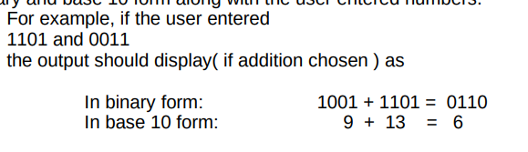
This is how a regular run of the program works for both addition and multiplication

Hello user. This program will add nad multiply 4 bit binary numbers

Do you wish to add or multiply the numbers?

Add or Multiply : Add
Please input the terms you are adding :
1001 1010
In binary form: 1001 + 1010 = 0011
In base 10 form: 9 + 10 = 3
Do you want to continue y/n : y

Hello user. This program will add nad multiply 4 bit binary numbers

Do you wish to add or multiply the numbers?

Add or Multiply : multiply
Please input the terms you are multiplying :
0001 0001
In binary form: 0001 x 0001 = 0001
In base 10 form: 1 x 1 = 1
Do you want to continue y/n : yes

